COINS-Eur-Constantine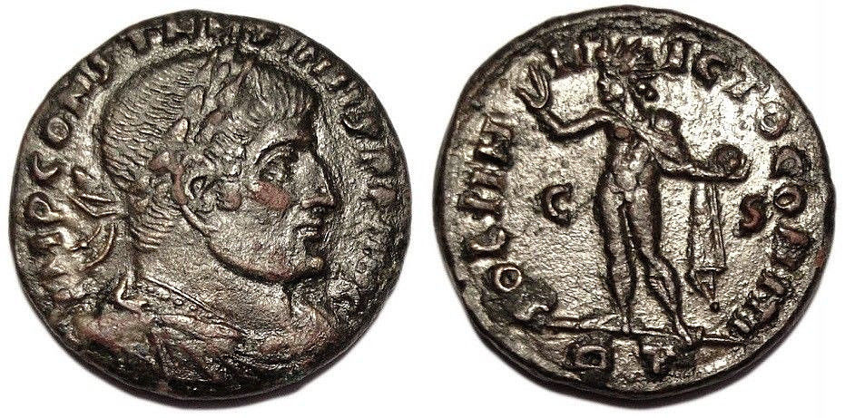

**CONSTANTINE I 315-316 AD Æ3 Roman Bronze Coin**

**Obverse legend: IMP CONSTANTINVS PF AVG (laureate, draped, cuirassed bust right)  
Reverse legend: SOLI INVICTO COMITI (Sol, radiate, standing left, chlamys across left shoulder, holding globe in left hand, C left field, S right)  
RIC VII 40 - Rome Mintmark(RT) (Rome, Italy)(45c55)**

Flavius Valerius Constantinus, Constantine the Great, was the son of Helena and the First Tetrarchic ruler Constantius I. Constantine is most famous for his conversion to Christianity after the battle of the Milvian Bridge where he defeated emperor Maxentius. Before the battle he saw the words "In Hoc Signo Victor Eris" (By this sign you shall conquer) emblazoned on the sun around the Chi Rho, the symbol of Christianity. After placing this Christogram on the shields of his army, he defeated his opponent and thus ruled the empire through divine providence. He also shifted the capital of the empire to Constantinople, establishing the foundation for an Empire that would last another 1000 years. He died in 337 and his sons divided the Roman territories.

**Diameter: 19,0 mm  
Weight: 3,30 g**

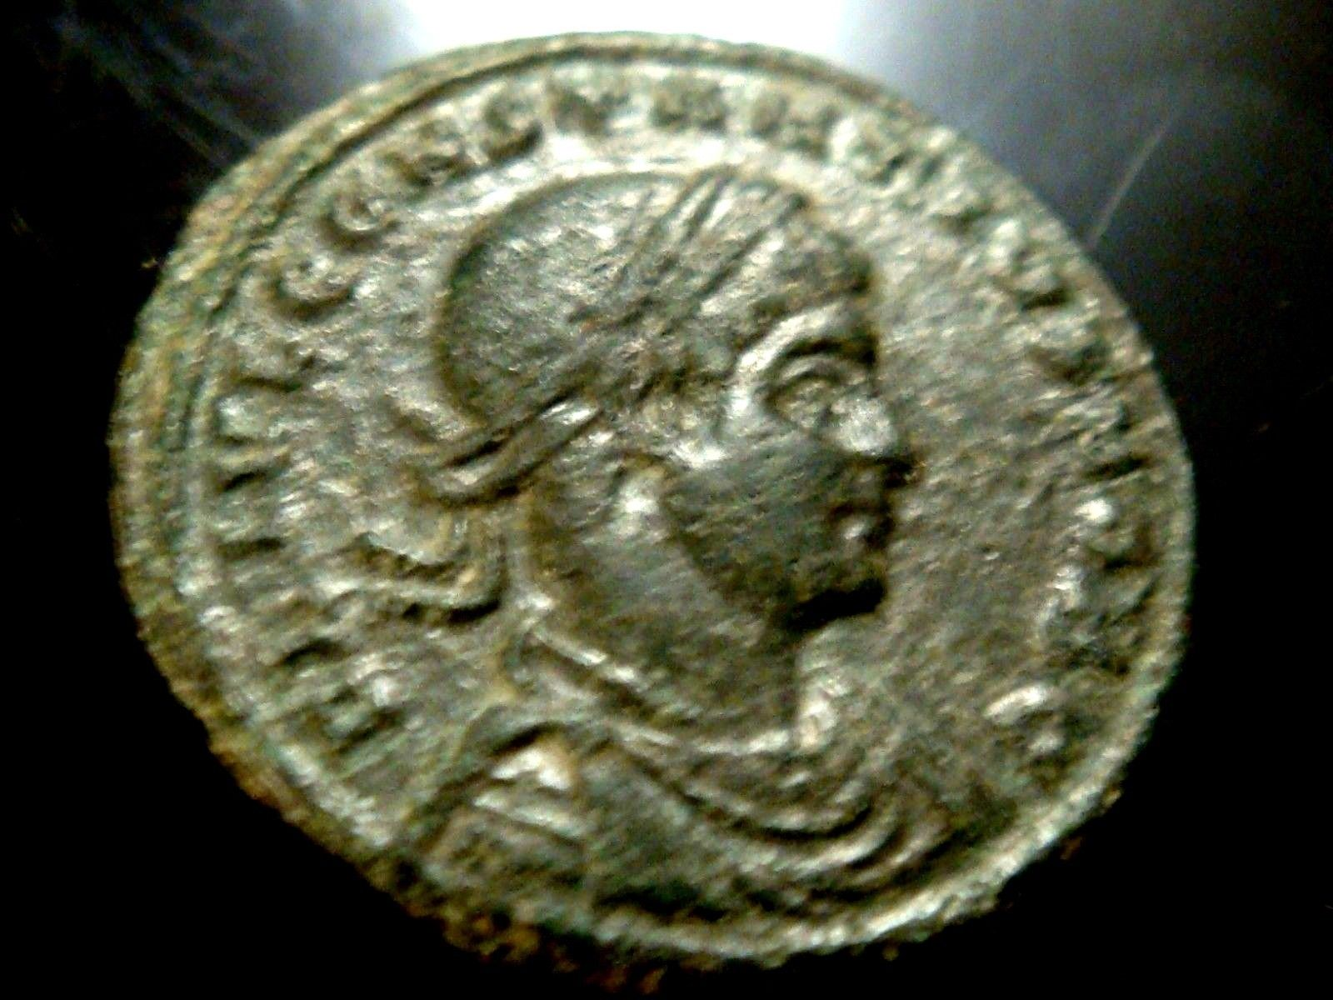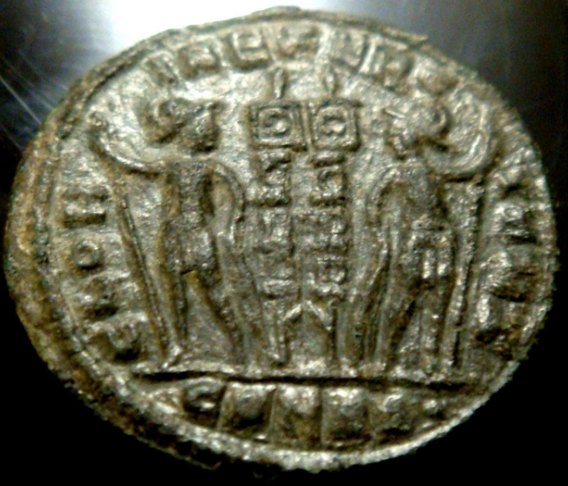

**PANTIKAPAION GOLD STATER**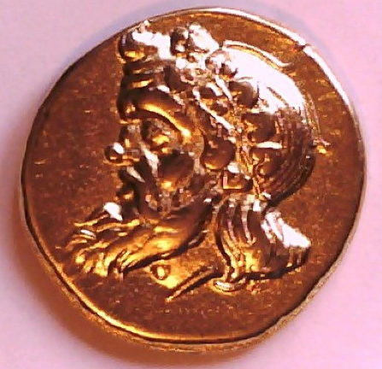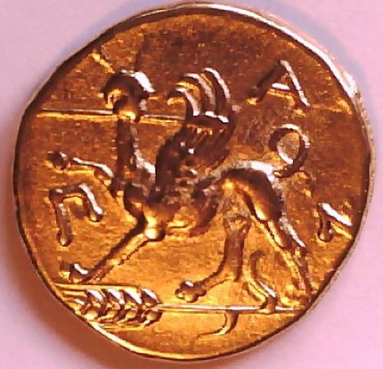

**SIZE/DIAMETER 20 MM**

***WEIGHT APPROX. 4 GRAMS***

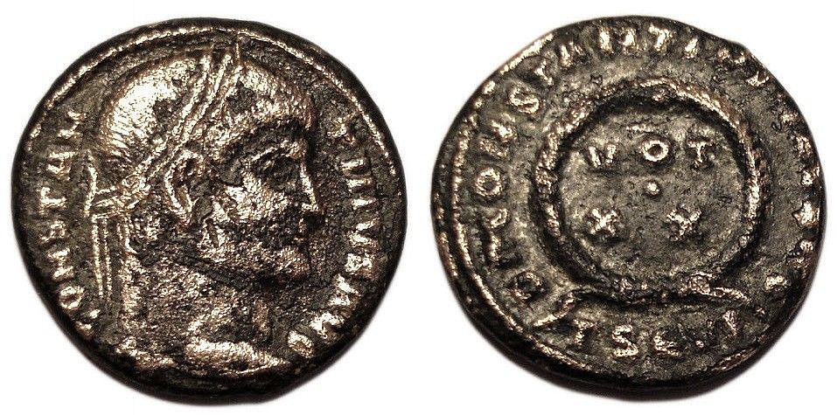

**CONSTANTINE I 320-321 AD Æ3 Roman Bronze Nummus Coin  
  
Obverse legend: CONSTANTINVS AVG (laureate bust right)  
Reverse legend: DN CONSTANTINI MAX AVG (wreath enclosing VOT XX)**

**RIC VII 117 - Thessalonica Mintmark(TSЄVI) (Salonika, Greece)(94c14)**

Flavius Valerius Constantinus, Constantine the Great, was the son of Helena and the First Tetrarchic ruler Constantius I. Constantine is most famous for his conversion to Christianity after the battle of the Milvian Bridge where he defeated emperor Maxentius. Before the battle he saw the words "In Hoc Signo Victor Eris" (By this sign you shall conquer) emblazoned on the sun around the Chi Rho, the symbol of Christianity. After placing this Christogram on the shields of his army, he defeated his opponent and thus ruled the empire through divine providence. He also shifted the capital of the empire to Constantinople, establishing the foundation for an Empire that would last another 1000 years. He died in 337 and his sons divided the Roman territories.

**Diameter: 18,7 mm  
Weight: 3,12 g**

**CONSTANTINE I 328-329 AD Æ Roman Bronze Coin Campgate Siscia**

[S](https://www.ebay.com/itm/CONSTANTINE-I-328-329-AD-E-Roman-Bronze-Coin-Campgate-Siscia-/183499947637?_trksid=p2047675.l2557&ssPageName=STRK%3AMEBIDX%3AIT&nma=true&si=o6AqUOpzyJfPTPyKHfGuzgeuN%252BM%253D&orig_cvip=true&nordt=true&rt=nc)

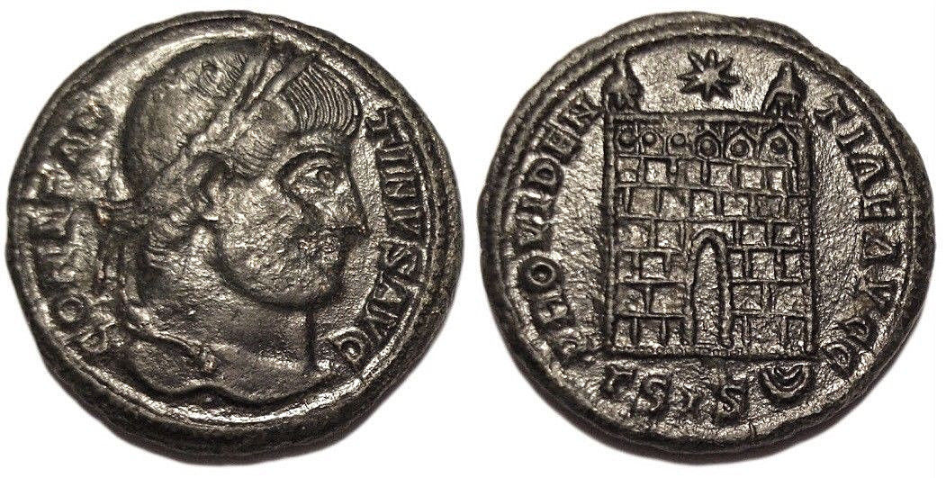 **CONSTANTINE I 328-329 AD Æ3 Roman Bronze Coin  
  
Obverse legend: CONSTANTINVS AVG (laureate head right)  
Reverse legend: PROVIDENTIAE AVGG (campgate with two turrets, star above)  
RIC VII 214 - Siscia Mintmark(ΓSIS-double crescent) (Sisak, Croatia)(94e97)**

Flavius Valerius Constantinus, Constantine the Great, was the son of Helena and the First Tetrarchic ruler Constantius I. Constantine is most famous for his conversion to Christianity after the battle of the Milvian Bridge where he defeated emperor Maxentius. Before the battle he saw the words "In Hoc Signo Victor Eris" (By this sign you shall conquer) emblazoned on the sun around the Chi Rho, the symbol of Christianity. After placing this Christogram on the shields of his army, he defeated his opponent and thus ruled the empire through divine providence. He also shifted the capital of the empire to Constantinople, establishing the foundation for an Empire that would last another 1000 years. He died in 337 and his sons divided the Roman territories.

**Diameter: 19,0 mm  
Weight: 3,11 g**

**CONSTANTINE I 315-316 AD Æ Roman Bronze Coin SOLI INVICTO COMITI Rome**



**ONSTANTINE I 315-316 AD Æ3 Roman Bronze Coin**

**Obverse legend: IMP CONSTANTINVS PF AVG (laureate, draped, cuirassed bust right)  
Reverse legend: SOLI INVICTO COMITI (Sol, radiate, standing left, chlamys across left shoulder, holding globe in left hand, C left field, S right)  
RIC VII 40 - Rome Mintmark(RT) (Rome, Italy)(45c55)**

Flavius Valerius Constantinus, Constantine the Great, was the son of Helena and the First Tetrarchic ruler Constantius I. Constantine is most famous for his conversion to Christianity after the battle of the Milvian Bridge where he defeated emperor Maxentius. Before the battle he saw the words "In Hoc Signo Victor Eris" (By this sign you shall conquer) emblazoned on the sun around the Chi Rho, the symbol of Christianity. After placing this Christogram on the shields of his army, he defeated his opponent and thus ruled the empire through divine providence. He also shifted the capital of the empire to Constantinople, establishing the foundation for an Empire that would last another 1000 years. He died in 337 and his sons divided the Roman territories.

**Diameter: 19,0 mm  
Weight: 3,30 g**

**ROMAN COIN AE FOLLIS CONSTANTINE I AUGUSTUS 307-337 AD NICOMEDIA IOVI CONSERVAT**

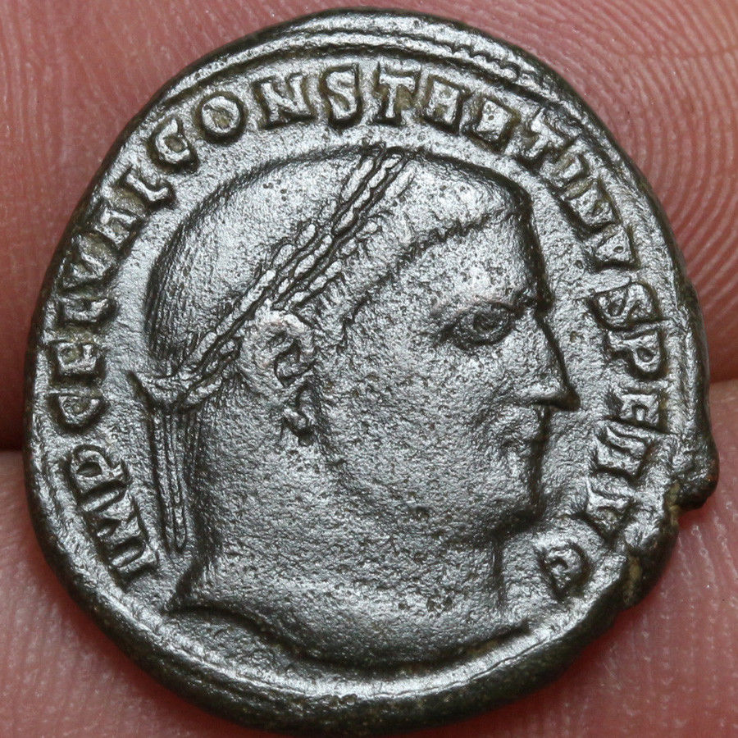 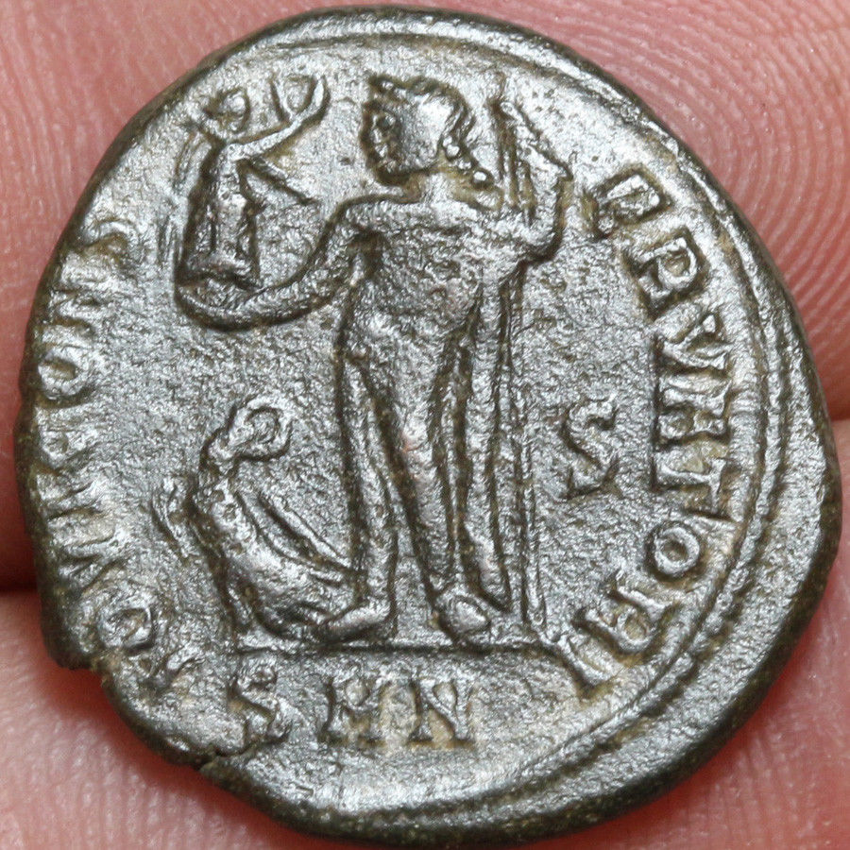 **ROMAN COIN AE FOLLIS CONSTANTINE I AUGUSTUS 307-337 AD  NICOMEDIA IOVI CONSERVATORI**

**Weight : 3.47gr**

**Size : 21mm**